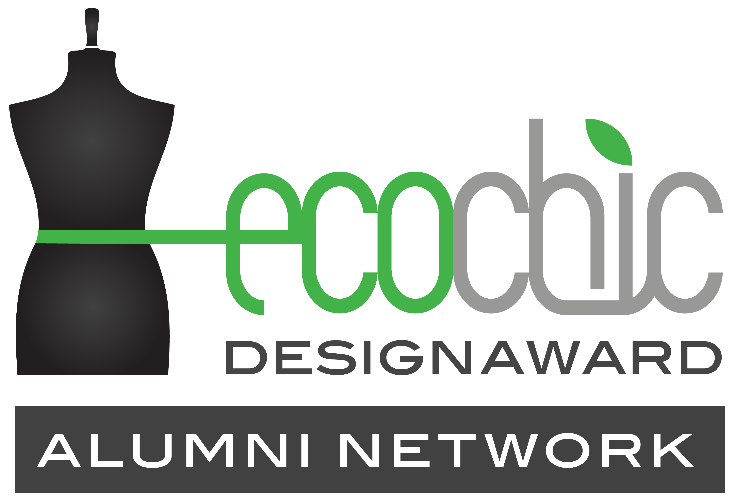

The EcoChic Design Award Alumni Network
Job and Internship Opportunities Template

If you would like to post a notice in The EcoChic Design Award Alumni Network LinkedIn group about a job, internship or exiting collaboration opportunity please fill in the below details and send it to info@ecochicdesignaward.com.

1. Post Details

Company Introduction:

Job title:

Job location:

Job description (i.e. responsibilities, requirements):

Salary:

Preferred posting date:

Application closing date:

2. Contact Details

Company name:

Contact person:

Email address:

Phone number (optional):

3. Acknowledgement of agreement

I acknowledge that the information on this application is true and correct, and hereby authorize Redress to release this information to “The EcoChic Design Award Alumni Network LinkedIn group”. I will notify Redress of any changes in the information provided on this form.

Signature: __ ______________________________
(Digital signatures or stamped signatures are acceptable)

Title:

Date:

